JAVA PROGRAMMING ASSIGNMENT

Experiment – 4

Name : Yash Saxena

Roll No. : 12213128

Branch : IT B (07)

Que 1 :

Code :

class student{

    static String name = "First";

    static{

        String k = "Second";

        student.print(k);

    }

    static void print(String k){

        System.out.println(k);

        System.out.println(name);

    }

}

public class Que_1{

    public static void main(String args[]){

        student a = new student();

    }

}

Output :

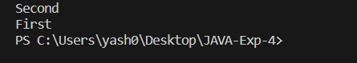

Que – 2 :

Code :

public class Que_2 {

    public static void main(String ...args){

        for(String i: args){

            System.out.println(i);

        }

    }

}

Output :

